Assignment Report

Deep learning 1402

Dr. Fatemizade

HW3

By Mohammad Amin Molaei Arpanahi

402011148

Q1

Part one

In the initial phase, I loaded the CIFAR dataset and filtered it to exclusively include images of cars and airplanes. Subsequently, I fine-tuned a neural network, opting for ResNet-50, which possesses an embedding space (size = (2048,))in its final fully connected layer. After attaching this layer, I added a sigmoid activation to compute the probabilities for the binary classes.

During training, I focused on learning only the weights of the last layer, while not setting the requires_grad attribute to True for all parameters. By manually adjusting the learning rate and batch size for the data loader, I achieved a training accuracy of approximately 100%. Moreover, the accuracy on the test dataset reached around 98%, indicating promising performance.

The corresponding visualizations for this phase are presented below.

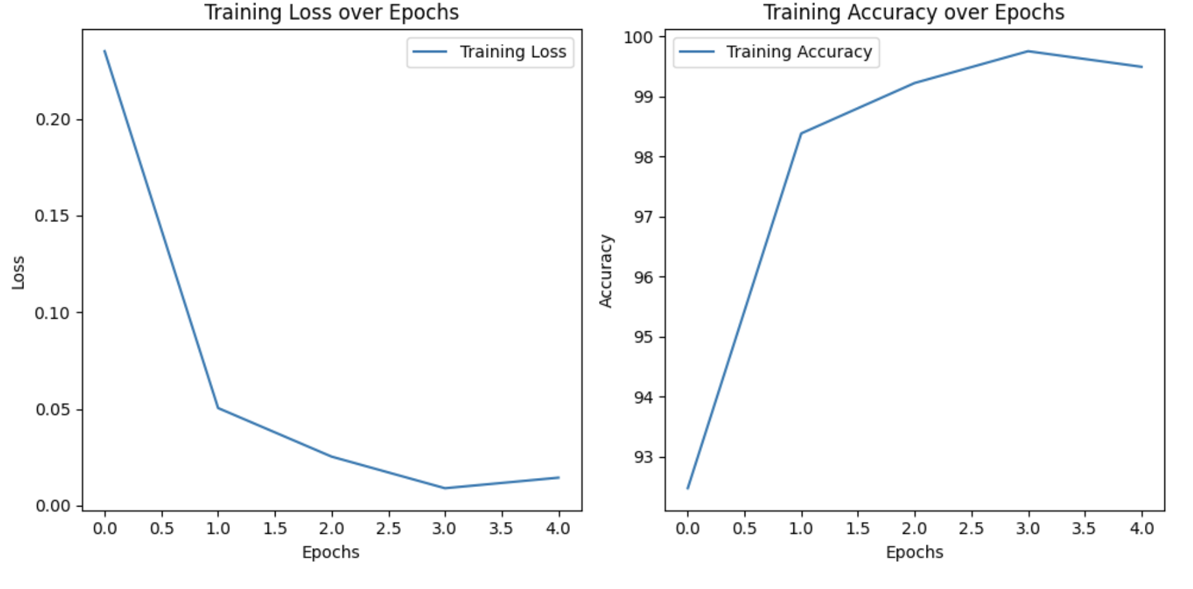

Part Two

In this phase, I constructed a dataset comprising anchor, positive, and negative samples to accurately compute the loss function in each epoch or batch. This structured dataset ensures the appropriate calculation of loss by pairing anchors with their corresponding positives and negatives, a requisite for proper training and optimization in each iteration.

I commenced by training a pre-trained ResNet-50 model to optimize feature extraction. This process aimed to generate embeddings where the representations of different classes are located farther apart in the feature space. Subsequently, I tailored the features specifically for the dataset.

I implemented the triplet loss function, which is indicative of the minimum distance between similar data points and the maximum distance between dissimilar data points. The loss trends are visualized in the plot below.

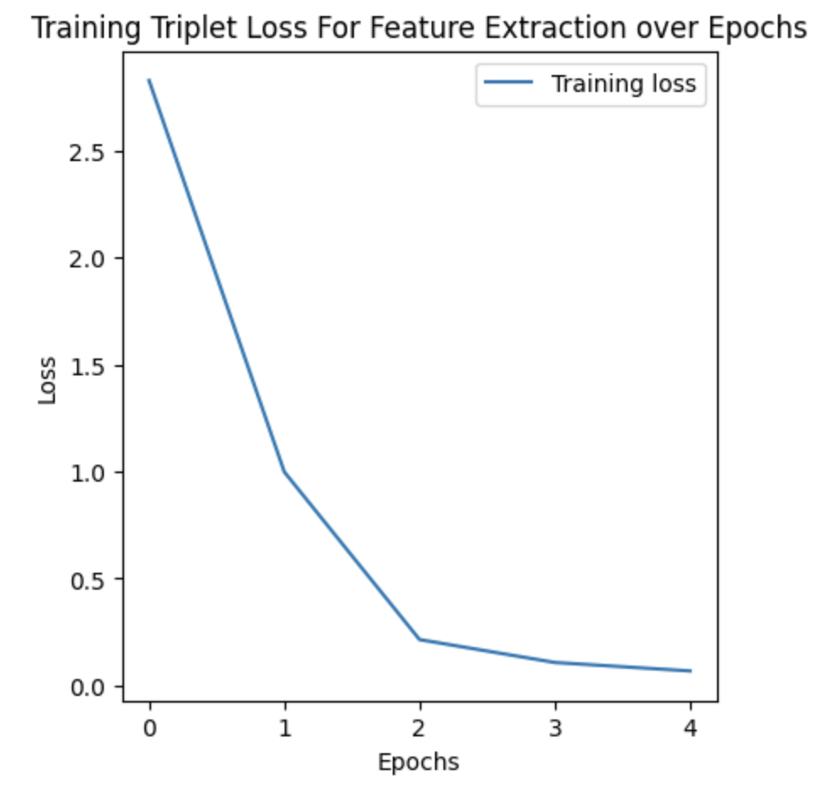

Upon completing the feature extraction phase, I appended a fully connected layer at the end of the model. This augmentation aimed to facilitate classification tasks, particularly to discern between cars and airplanes. Subsequently, I proceeded to train the modified model using the extracted features to enhance the classification accuracy.

The corresponding visualizations for this phase are presented below.

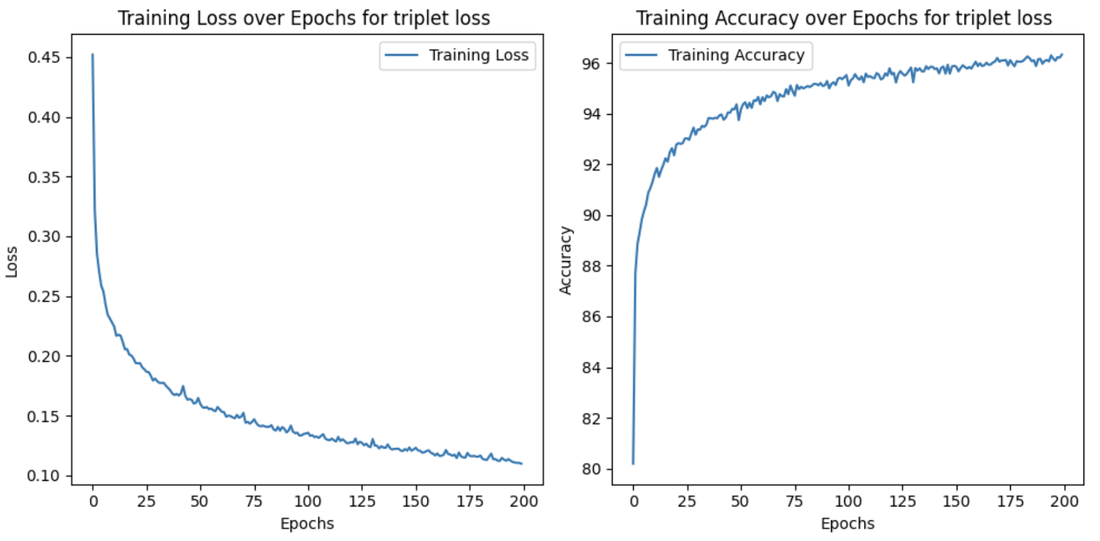

Part Three

In the final segment of this assignment, I incorporated the calculation of triplet loss alongside binary cross-entropy loss during each epoch and batch. This combined approach enabled simultaneous training of the model to minimize both losses. For every batch iteration, I directly generated anchor, positive, and negative data from the dataset used in the initial phase. This approach was chosen as it necessitated access to the labels for BCE loss.

Upon completing the training phase, the model achieved the following results. It's important to highlight that no model selection techniques were employed, and the learning rate and batch size were determined through multiple trials and experimentation.

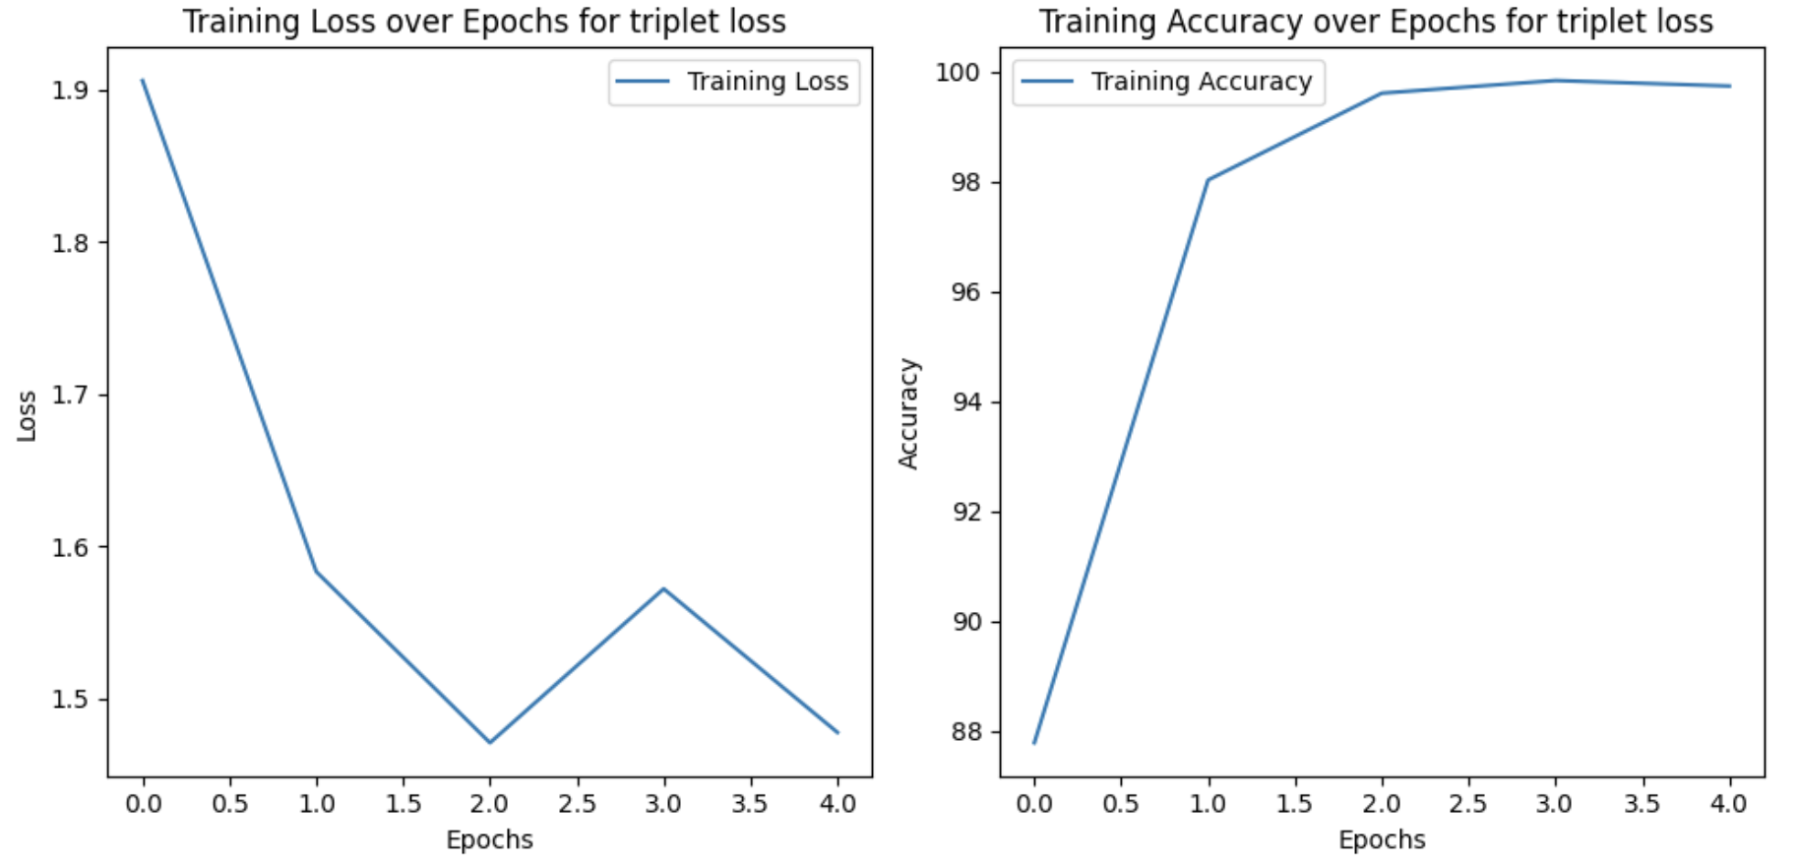

Q3

**Data preparation**

To prepare my dataset for training, validation, and testing, I developed functions to perform displacement, rotation, and scaling on the images. The displacement function involves randomly shifting the image by a certain percentage and returning the shifted image. For rotation, I applied a random degree rotation within the range of 15 to 30 degrees and then selected the largest image without any dark areas, saving the index of the largest square for cropping the original image. This step helped eliminate scaling biases in the rotation class.

Regarding the scaling function, I resized the image by selecting a random coefficient and then cropped it back to its original shape. This resulted in the image being scaled up by a factor of 1 divided by the scaling rate. After applying these functions to the original images, I created a data loader with a batch size of 32 due to limitations in GPU RAM.

I also passed some input to my data sets so you can change that and train the model in very shorter time.

I also adjusted the label classification to enhance the understanding of the images. The images corresponding to each label are displayed below.

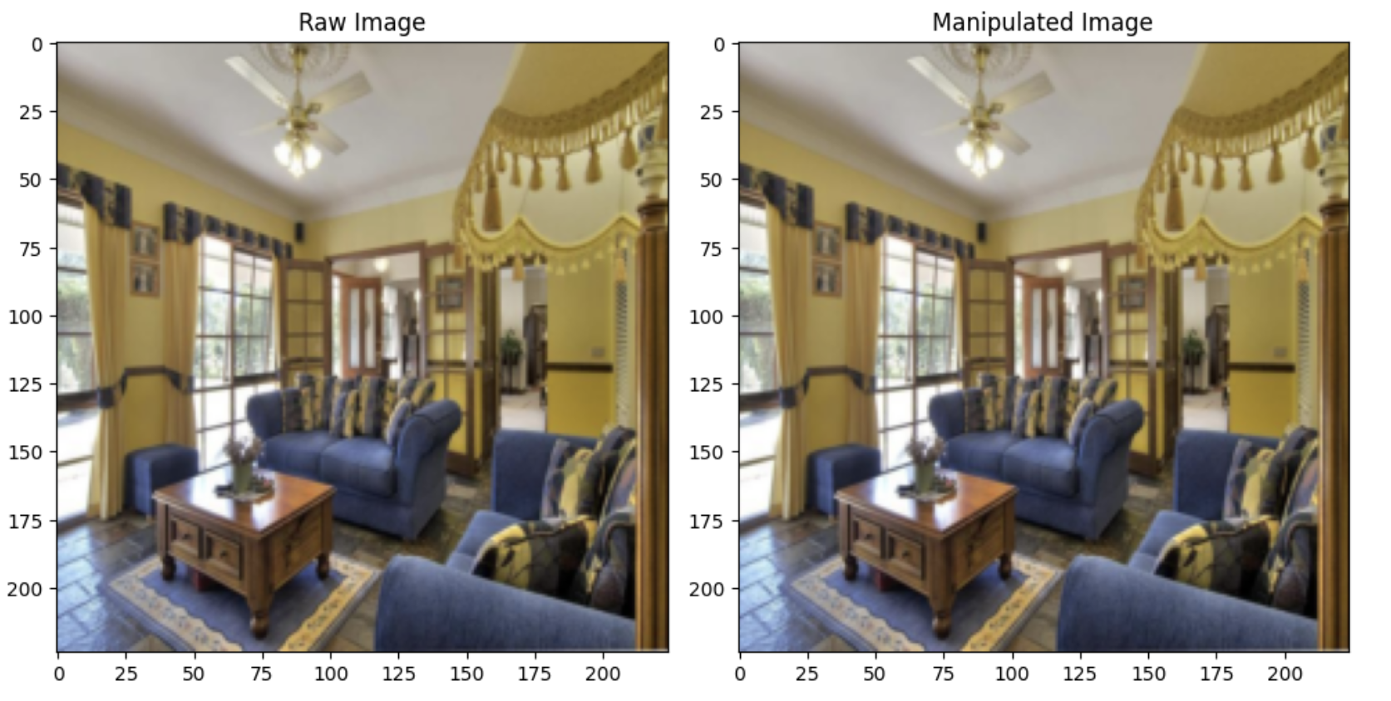

Figure – Unchanged image (label = 0)

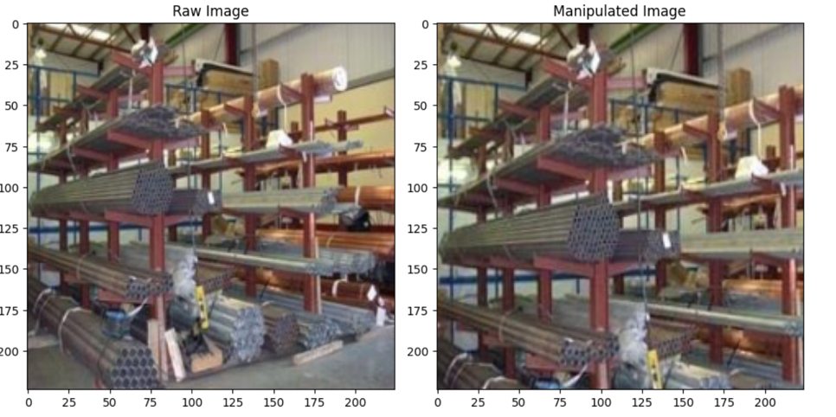

Figure 2 – Displacement (label = 1)

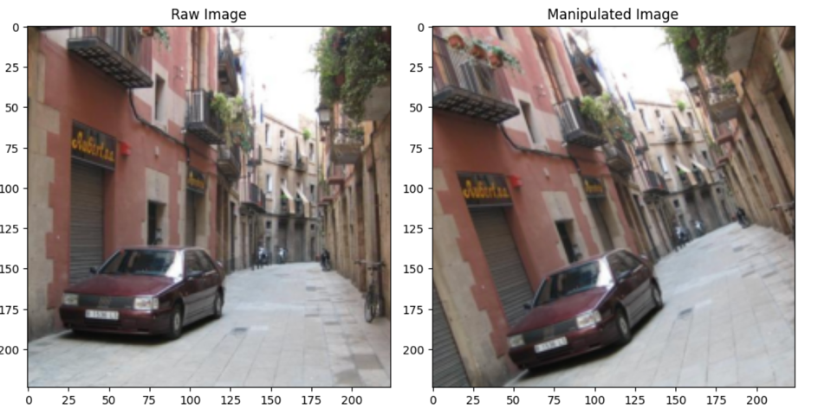

Figure 3 – Rotation (label = 2)

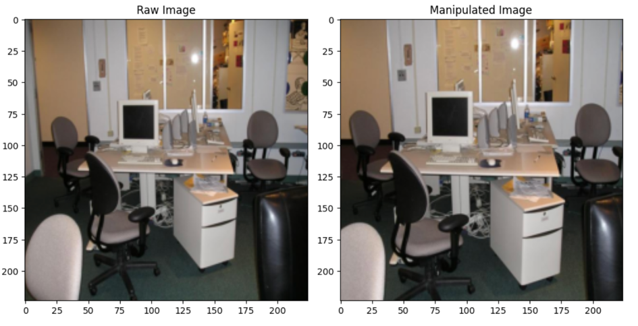

Figure 4 – Scaling (label = 3)

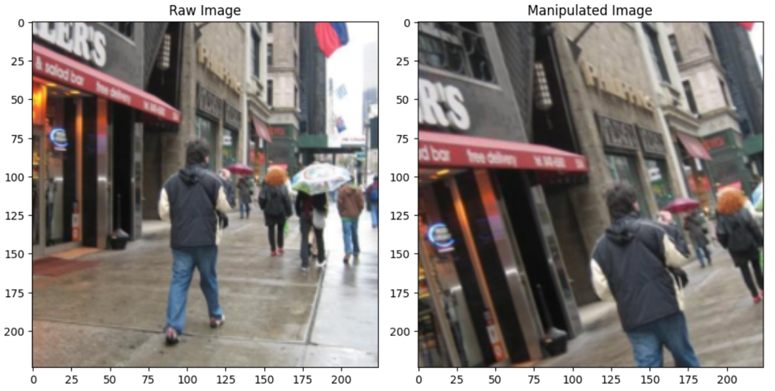

Figure 5 – Displacement and Rotation (label=4)

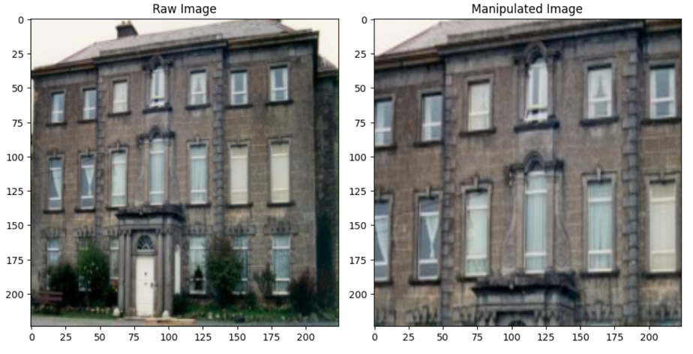

Figure 6 – Displacement and Scaling (label=5)

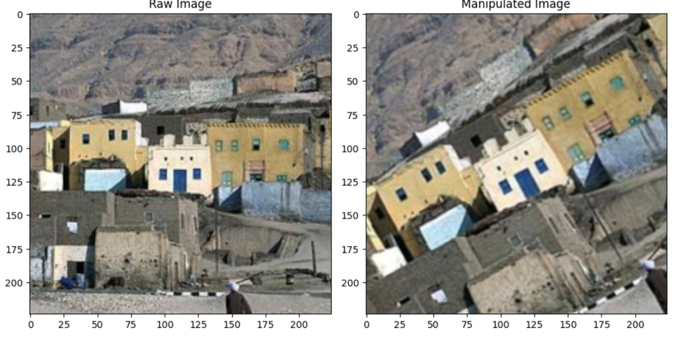

Figure 7 – Rotation and Scaling (label=6)

**Train and Validation**

After setting up the data loaders, I populated the classes to construct the "changer" model, designed to detect image manipulations. Once these initial steps were completed, I commenced training the model to update its parameters and classify paired images. Simultaneously, I evaluated the model's performance by assessing the error rate and accuracy on the validation set to determine its effectiveness on unseen data. Finally, I saved the trained model.

I utilized the following hyperparameters for my model:

* Optimizer: Adam
* Learning rate: 0.0001
* Number of epochs: 20
* Batch size: 32

The obtained results after training are as follows:

* Accuracy on the training set: 94.6%
* Accuracy on the validation set: 90%
* Average training loss: 1.28
* Average validation loss: 1.30

Below is the plot depicting the training and validation loss versus the epoch number.

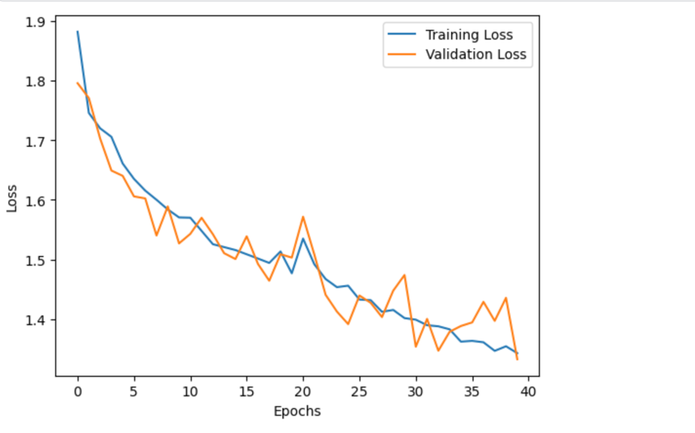

**Testing**

In this phase, I tested my model on 4000 input data samples containing pairs of original images and their corresponding changed images. The model achieved an accuracy of **85 percent** on the test set.

I employed the scikit-learn module to compute the confusion matrix, which provided insights into the accuracy for each class and misinterpreted classes. The confusion matrix is presented below.

Confusion Matrix:

[[495 0 0 0 0 0 0]

[ 0 447 0 0 3 29 1]

[ 3 2 394 24 11 17 24]

[ 0 5 0 468 0 6 0]

[ 1 1 4 0 360 105 4]

[ 0 19 0 2 4 427 0]

[ 1 2 69 40 32 105 247]]

The model has better performance for some classes.

The accuracy for one change is somehow better than the input including two changes.

My model has ‌ a little lower accuracy for rotation + scaling classes.

* I added some lines of code due to free the torch GPU RAM.
* I Answered the questions in notebook as below.

سوالات تئوری:

سوال تئوری1:

مقادیر زیر را برای لایه های کانولوشن چه قدر در نظر گرفته اید؟

channel out size (conv(1*1))

padding(conv)

دلیل استفاده از کانولوشن 1در1 چیست؟

با توجه به این که دو مسیر با یکدیگر جمع می شوند باید تعداد کانال ها در مسیر سمت راست با تعداد کانال در

مسیر سمت چپ برابر باشد به عبارتی چون خروجی بعد از جمع شوند تغییر کانال نمیدهد تعداد کانال های

خروجی دقیقا باید برابر تعداد کانال خروجی بلاک ، استیج که در شکل اول قابل مشاهده است برداشت شود.

پدینگ در این کانولوشن یک در یک طبیعتا باید صفر باشد چرا که در صورت انتخاب حاشیه اطلاعاتی از خود ورودی به دست نمی آید.

کانولوشن یک در یک برای یادگیری اطلاعات کانال و تغییر تعداد کانال به صورت قابل یادگیری استفاده می شود.

بررسی کنید عکس ها با یک ،2 یا 3 تغییر کدام بهتر تشخیص داده میشوند؟

با توجه به کانفیوجن ماتریس بالا مدل به طور کلی به ترتیب برای کلاس های بدون تغییر و کلاس های با یک تغییر و دو تغییر بهترین عملکرد را داراست.